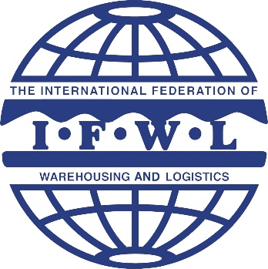

for The International Federation of Warehousing and Logistics

MRS. ZHOU WUXIU
Tel: +86(0)10 6336 1361 E-MAIL: zhouwuxiu@cawd.org.cn
1605,Building B, LangQin International, NO.168,Guanganmenwai,Beijing, China

NATIONAL & REGIONAL ASSOCIATION ONLY
YOUR ASSOCIATION

ASSOCIATION INFORMATION
Please state the address (number, street name, etc.) to be used, where should correspondence be sent by registered letter or other means of delivery.
Association name : Establish ：
Country : Address ：
Office : Fax :
Website : E-mail :
JURIDICAL PERSON
Owner : ⃞ Mr ⃞ Mrs Name :
Title : Cell :
Office : E-mail :
CONTACT INFORMATION
Attention : This person will receive all correspondence regarding your participation.
⃞ Same address as the association’s
⃞ To be sent to the address mentioned below：

Contact person : ⃞ Mr ⃞ Mrs Name :
Title : Cell :
Office : E-mail :
INDUSTRY AND MEMBERSHIP INFORMATIO
How many membership companies related to warehousing and logistics? :

Totally amount of national or regional warehouse which is operated at room temperature by members is __________ square meters, capacity of cold storage is __________ cubic meters.

Do you have any national or regional technical qualifications, standard or measurement on warehouse, warehousing service, warehousing performance? If yes, list please.

How Many company Members：
Totally Amount of Warehouse which is operated at room temperature by company members is __________ square meters,
capacity of cold storage is __________ cubic meters.
Facility Ratio of Association members out of Country ：
Membership Composition：
⃞ Warehousing and Distribution | ⃞ Distribution or Express, Express Delivery
⃞ Integrated Logistics | ⃞ Supply Chain Service
⃞ Manufacture | ⃞ Consulting Service
⃞ Wholesale or Distribution | ⃞ Retail
⃞ E-commerce or Cross-border E-commerce | ⃞ E-commerce or Cross-border E-commerce

4、
DEMAND FOR COOPERATION
⃞ Co-organize IFWL Annual Conference for Membership
⃞ Co-organize Trade Fair on Supply Chain
⃞ Co-organize Business Match-making
⃞ Take Part in International Visit Delegation（Country： Where： When： ）
⃞ Take Part in the Promotion of Warehousing Technical Qualifications
⃞ Certify on Warehouse Grades and Warehousing Service Quality
⃞ Co-construct win-win Warehousing Resources Shared globally
⃞ Project Consulting Service （Details ： ）
⃞ IFWL Yearly Sponsor
⃞ Others （ ）
OTHERS

Should you have any request and suggestion, please feel free to let us know.：

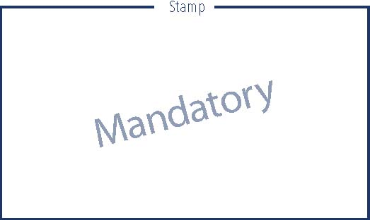
MEMBERSHIP UNDERTAKING
Notify that we are pleased to join IFWL on condition that obey
the articles.

Signature Date

